ADAGIO UNVEILS EXCITING REBRAND FOR 2023

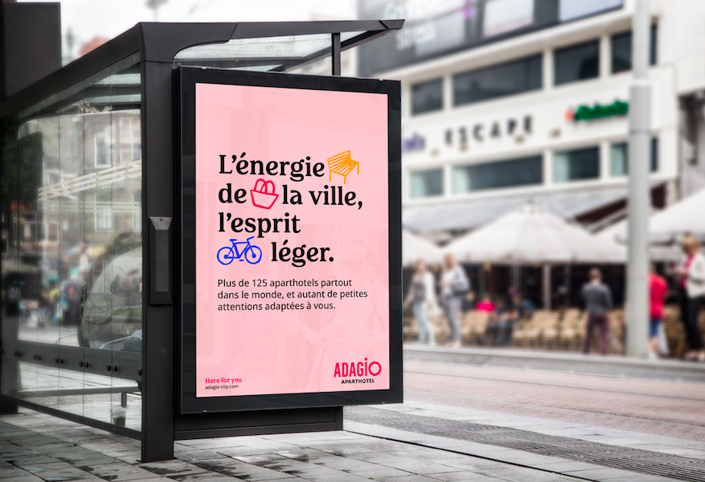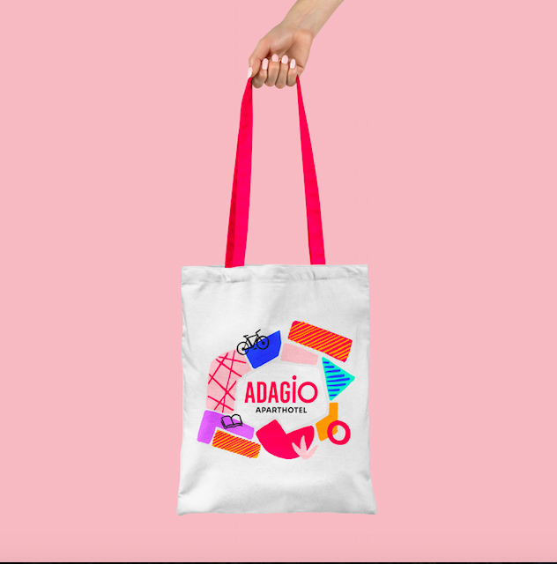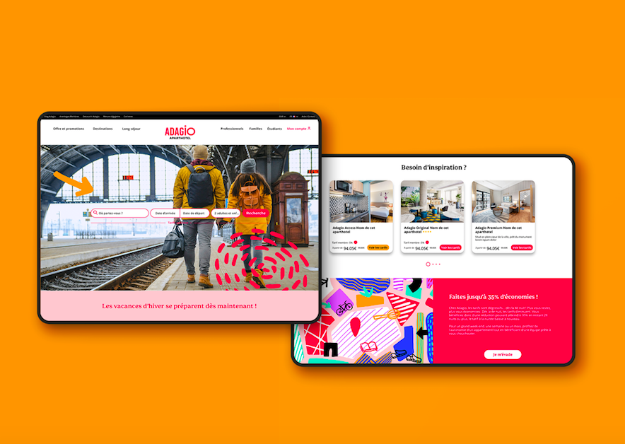

Europe’s leading serviced apartment brand, Adagio, is delighted to launch a full rebrand this month. The contemporary, vibrant new look and feel represents Adagio’s progression and ambitions for its continued growth in 2023 and beyond. Representing Adagio’s three ranges: Access, Original and Premium, the striking new branding features a bold and eye catching colour scheme illustrating a set of new brand messages.

With this re-brand, Adagio aims to strengthen its position as a leader and forerunner in the aparthotel sector, enhance its international development and position itself as a responsible brand that acts for the transition of cities.

The rebranding has been designed to illustrate a collection of new messages encompassing Adagio’s purpose, promise, mission, values and proof of achievements including:

- Purpose - Making Life in The City More Beautiful – by committing to strong human interactions, social and environmental responsibility and a focus on local communities, Adagio reveals the beauty of cities, injecting colour and joy into city life.
- Promise – The City Made Easy - Adagio’s operational efficiency and versatility means guests are free to enjoy and discover the city carefree.
- Mission – Making It Easier For Guests To Enjoy Life In The City - Adagio aims to create long- term, personal relationships with guests to develop unique customer insights allowing them to tailor stays to the individual’s needs.
- Values - Adagio employees uphold the key values of:
  - Sharing (solidifying bonds between staff and customers through programmes such as Be My Guest)
  - Daring (upholding a strong and unique identity as a European market leader with 125 aparthotels on 4 continents)
  - Responsibility - (ensuring Adagio continues to grow in a sustainable way through reducing our impact to be more energy efficient, acting collectively to be a responsible employer and with committed employees, and growing our local community connections within the city)
- Proof - Adagio’s achievements over the last 12 months include 5 European openings, 85K repeat customers, major new business wins including Deutsche Bank and IES Abroad, and an average occupancy rate of 84% from June-October 2022

Adagio’s rebrand has been created by branding agency Saguez & Partners who aimed to transform the brand by creating impact, meaning and uniqueness through a modern new look and feel. The agency took inspiration from artists renowned for their bold use of colour including Matisse and David Hockney. The colour palate features bright shades of orange, turquoise, pale pink, purple and black alongside the brand’s existing signature red.
The focal point of the rebrand is the new Creative City Map - a colourful, bold design which represents the modern city landscape within which Adagio properties are located. The design puts Adagio at the heart of the city’s energy and amplifies the brand’s potential with a positive, enthusiastic, creative and lively space.
Karine Eisenchteter Léothier, Director of Strategy and Innovation Saguez & Partners says: “We have revealed a powerful, modern and light brand. We are very happy with the result, which lives up to our common ambition: to reveal the brand's potential, to change the perception of Adagio by placing it in a modern context with a rich and lively territory.”
Laurène Rohr, Head of Marketing at Adagio says: “We are delighted to reveal our new brand platform which is a concise expression of Adagio’s identity. Our aim with this modern new look is to take Adagio into a new phase. We want to reach new customers as well as nurture our existing ones through our new messages and branding which are key to our continued growth in the aparthotel and wider travel sector”.
Consumers can expect to see Adagio’s new branding across both digital and out of home advertising including website, social media, billboards and on branded merchandise from this month.

ABOUT APARTHOTELS ADAGIO:

About Aparthotels Adagio

Adagio combines the comfort of a flat with the services of a hotel for added convenience. Mainly found in city centres and sought-after regions. The innovative company Adagio was founded in France in 2007 as a joint venture between Accor and Pierre & Vacances Center Parcs. The idea was to offer a concept for the needs of long-term travellers. What was originally 16 aparthotels in two countries has now become a rapidly growing company with the aim of being present in Europe as well as in the Middle East and Latin America. Today, Adagio is the European market leader in the aparthotel sector and aims to expand its network to a total of 200 aparthotels with 15,000 flats by 2024. The three product lines are: Adagio Original: the heart of Adagio; Adagio access: the essence of Adagio, Adagio Premium: the exceptional Adagio.

Find Adagio on Instagram, Facebook, LinkedIn and Youtube.

Mason Williams Communications

Mason Williams is a consumer lifestyle agency. Launched in 1986 it has offices in London, Manchester and Spain and is part of the IPREX network with 62 offices globally. The agency specialises in consumer brands across a number of sectors: family, leisure, food and drink, destinations, hotel and hospitality, luxury, travel and outdoor entertainment.

Visit www.mason-williams.co.uk or find us on Twitter @MasonWiliamsPR, Facebook Mason Williams PR, and Instagram @masonwilliamspr

For further information on Adagio, please contact:
Iram Khawaja | iram@mason-williams.com | 07827 062383
Syamala Upham | syamala@mason-williams.com | 07825 417148

Offices: London, Manchester, Mallorca & Globally with IPREX

London: Level 19, 1 Westfield Avenue, London E20 1HZ
Manchester: 20 Vancouver Quay, Salford Quays, Manchester M50 3TT
Mallorca: Casa Lucem, Ruberts, Sineu, 07220 Mallorca, Balearic Islands

