A Vibrant New Aparthotel in The Pink City:
Adagio Original Toulouse Centre La Grave

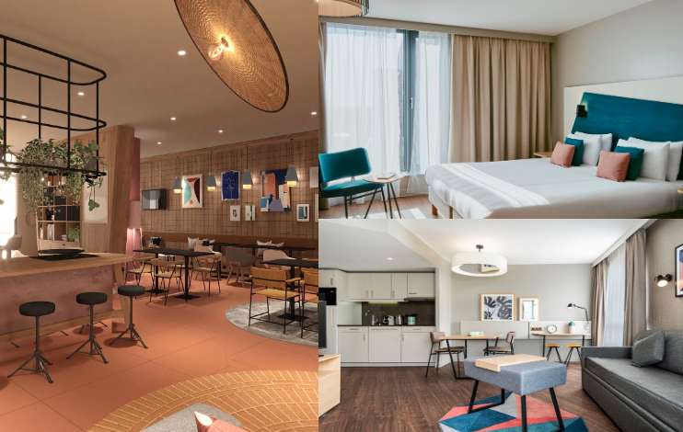

Adagio celebrates the cultural beauty of Toulouse by welcoming a vibrant, warm and committed new aparthotel on July 31st 2023.

For its fourth establishment in the pink city, Adagio has chosen to settle in rue du Pont Saint-Pierre in the lively and commercial district of Saint Cyprien. The new aparthotel has 114 apartments that can accommodate up to 6 people, ideally located at the foot of the dome of La Grave at the very heart of Toulouse life.

In collaboration with Didier Versavel's design studio, Adagio Original Toulouse Centre La Grave draws its energy from the good vibes of the city to relay them to its guests whether they are urban travellers and short, medium or long-term business travellers. It is an ideal place to recharge your batteries and immerse yourself in the gentle, convivial exaltation of the South-West.

Adagio Original Toulouse Centre La Grave aims to be a lively place for Toulouse residents, combining the flexibility of an apartment and the services of a hotel. This new establishment is the best solution for medium and long stays, offering the best value for money to business and leisure travellers, and to those who like to be both at the same time.

From the undulations of the Garonne to the benevolent curves of the dome of La Grave, passing by the iconic arches of the Saint Pierre bridge, each emblematic place of the city comes to nourish the inspiration of Didier Versavel's design studio, all united by positive vibes and festive Toulouse.

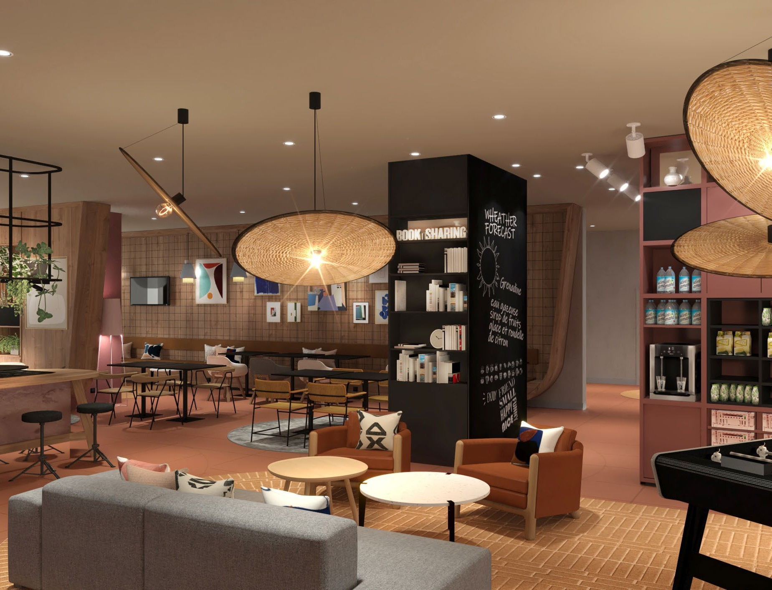

The artistic choices and interior architecture of the new Adagio establishment reflect these local “markers”.

As soon as guests enter, an XXL mural handmade by local artist Nuublaa welcomes visitors. Nuublaa offers an abstract and minimal vision of the city, paying homage through it to the remains of the Couvent des Jacobins, the verdant Jardin des Plantes and Jardin Royal or even the Canal du Midi.

The common areas, unifying living spaces have been designed like a village within the city, inspired by the authentic cobbled communal squares and bastides of the Midi-Pyrénées, which bring residents and businesses together in the centre. A selection of artworks, from Wilo & Grove Galerie, adorns the walls. While the brick and pink stone, reminiscent of the beautiful summer evenings on Place Wilson, warm up the characterful wood of the furniture and the woven wicker of the lamps and seats.

This authentic and rich atmosphere immerses visitors in a timeless, friendly, vibrant and committed summer languor.

In an approach of emotional, functional, and ecological responsibility, Adagio has favoured local furnishing partners to help to reduce the project's energy consumption with:

- Selency, specialise in second-hand furniture for the common areas
- Alki, local designer and manufacturer in the Basque country
- Ecobirdy and Tiptoe, specialise in kid’s furniture from recycled materials to use in the Kid’s Corner

With this new aparthotel, Adagio unveils a living space embodied by its values ​​and its commitments. A virtuous design bias that stands out from standardized establishments.

-ENDS-

About Adagio
Adagio is the European leader of aparthotels. Founded in France in 2007 as a joint venture between Accor and Pierre & Vacances Center Parcs, Adagio boasts 129 sites and 14,071 apartments, located in 16 countries. It is the most extensive aparthotels network in Europe.

Combining the flexibility of a flat with the services usually found in hotels, aparthotels are the best solution for medium to long stays, providing the best value-for-money to business and leisure travelers alike, and to those that like to combine both.

Located in urban areas, Adagio’s aparthotels are divided in 3 ranges: Adagio Original, in the centers of major cities; Adagio Access, in the center of regional capitals or in the direct outskirts of larger cities; and Adagio Premium, high-class aparthotels.

Mason Williams Communications
Mason Williams is a Public Relations agency specialising in Consumer Lifestyle brands. Founded in 1986 we have worked with, and currently represent, some of the biggest and most exciting brands, products and names in the UK and globally through our network IPREX. We have key senior directors based in London, Manchester, Cornwall, and Mallorca to handle our growing Spanish brands.

Visit www.mason-williams.co.uk or find us on Twitter @MasonWiliamsPR, Facebook Mason Williams PR, and Instagram @masonwilliamspr
For further information on Adagio, please contact:
Syamala Upham | syamala@mason-williams.com +44 7825 417148
Iram Khawaja | iram@mason-williams.com +44 7827 062383
Rita Rowe rita@mason-williams.com +44 7711 071451

