Adagio Launches New Advertising Campaign: Aparthotels Where You Feel at Home, Everywhere

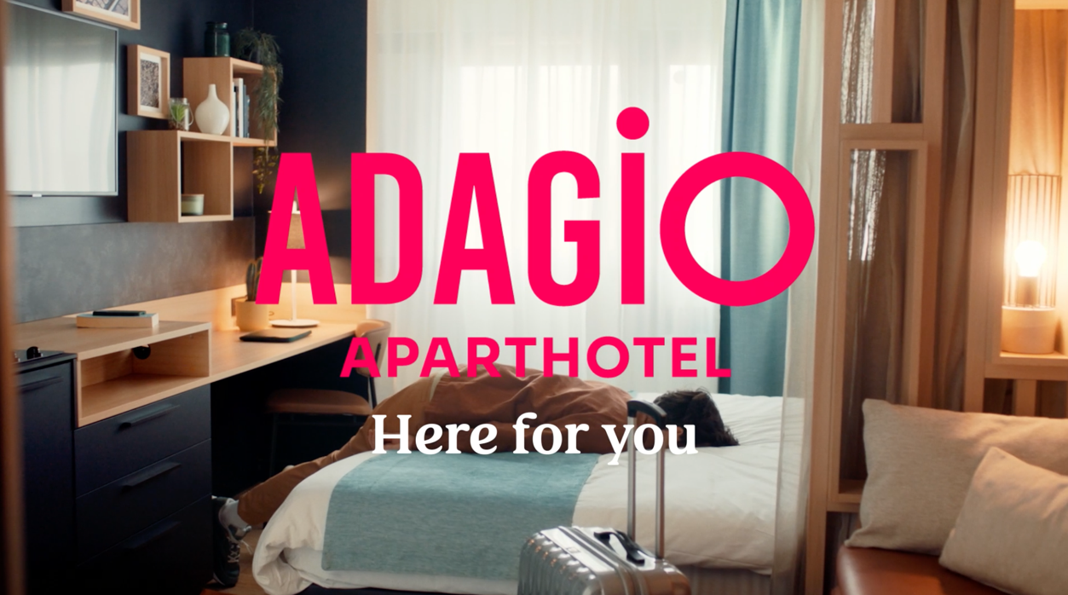

April 2023: Adagio is returning to the screens from April 13, with a new advertising campaign (with three films in French, English and German) directed by French communications agency Josiane to support the development of the Adagio brand in France and Europe.

In February this year, Adagio unveiled its new brand identity with a redesigned graphic universe and a strong positioning, focusing on a new slogan “Here For You” in efforts to establish its position as the leader in the European aparthotel industry.

The new campaign focuses on the message “I Lived There” to make Adagio customers feel at home in the brand's aparthotels. The aim is to highlight, with humour and realism, a profound change in our societies, which increasingly values the use of different properties over ownership.

The creative idea stems from the observation that having a place of your own, where you go to all the time, was the aspiration of our elders. Adagio aims to meet the new desire of being able to discover a new place and still feel at home. It is to this paradox that Adagio responds: to be at home, everywhere, without being an owner. With Adagio, you can "live" everywhere, in the most beautiful cities, and immerse yourself in local life. Guests are welcomed by staff who are keen to share their recommendations and you will feel at home. With Adagio, you no longer feel like a tourist, but a real local. We experience the city as if we lived there.

In two films, particular emphasis is placed on the experience of local gastronomy – which is always at the heart of the discovery of a destination. There is also a focus on beautiful human encounters that give each city a face, revealing all the generosity shown by Adagio staff. This attention allows guests a new experience of the city: because the city is more beautiful when it is shared.

In addition to the video films, Adagio will share visuals adapted for the campaign throughout the year. In each movie, a key customer benefit will be highlighted: more than a tourist/traveller, become a Parisian, a Londoner, an Amsterdammer, etc.

For Xavier Desaulles, Managing Director of Adagio, this campaign demonstrates how much the Adagio offer corresponds to our new lifestyles: “The world is changing, and so are we. We want to “live” much more than just “have”! Having a place of your own for holidays or weekends and going to the same place all the time is outdated. Today, we want fewer constraints, more simplicity, and the chance to discover more. We want to be able to go everywhere and feel at home there. Be greeted when you arrive. Find your marks by putting down your suitcases. Being able to go out and immerse yourself in local life, but also be able to stay cocooned in the warmth and make yourself a good meal. Wanting the advantages of a home without the disadvantages may be paradoxical but at Adagio, we find it natural. In our aparthotels, you can have it all at the same time. Be at home, everywhere, without having the constraints. The best of both worlds… what if that was true modernity?”

Laurent Allias, Founder of Josiane:
“Thanks to the Adagio teams who generously share their knowledge of the city, we are treated like we are home while having access to all the great recommendations and local people… for guests it feels like they have become inhabitants of the city they have visited at the end of their stay instead of a tourist or a commuter. We imagined a character, who is a little cocky and appropriates with all the cities he has visited for barely 2 or 3 days, boasting about all the knowledge he has gained. “Ah Rome… I used to live there”, “How, you don’t know so and so?”, “Malta? I lived there!" etc”

The campaign will be broadcasted on TV and digitally across France and Germany while the focus for the UK is digital only from 13th April for the duration of 6 weeks.

Formats: 30' on TV and VOL and 15' on social media.

Credits:
Advertiser: Adagio
Agency: Josiane
Agency Manager: Laurent Allias
Advertiser Manager: Xavier Desaulles, Laurène Rohr, Sarah Bendaoud
Strategy Director: Evelyne Bourdonné
Strategic planner: Clara Laffont
Creative Director: Jérôme Diez
Artistic Director: Théo Le Douaron
Copywriter: Romain Grange
Account Director: Fanny Kemp
Project manager: Léa Roux
Production: Animal Animal
Director: Julien Carpentier

-ENDS-

About Adagio

Adagio combines the comfort of a flat with the services of a hotel for added convenience. Mainly found in city centres and sought-after regions. The innovative company Adagio was founded in France in 2007 as a joint venture between Accor and Pierre & Vacances Center Parcs. The idea was to offer a concept for the needs of long-term travellers. What was originally 16 aparthotels in two countries has now become a rapidly growing company with the aim of being present in Europe as well as in the Middle East and Latin America. Today, Adagio is the European market leader in the aparthotel sector and aims to expand its network to a total of 200 aparthotels with 15,000 flats by 2024. The three product lines are: Adagio Original: the heart of Adagio; Adagio access: the essence of Adagio, Adagio Premium: the exceptional Adagio.

Find Adagio on Instagram, Facebook, LinkedIn and Youtube.

For more information visit Adagio and follow them on Instagram, Facebook and Linked In.

Mason Williams Communications
Mason Williams is a Public Relations agency specialising in Consumer Lifestyle brands. Founded in 1986 we have worked with, and currently represent, some of the biggest and most exciting brands, products and names in the UK and globally through our network IPREX. We have key senior directors based in London, Manchester, Cornwall, and Mallorca to handle our growing Spanish brands.

Visit www.mason-williams.co.uk or find us on Twitter @MasonWiliamsPR, Facebook Mason Williams PR, and Instagram @masonwilliamspr
For further information on Adagio, please contact:
Syamala Upham | syamala@mason-williams.com +44 7825 417148
Iram Khawaja | iram@mason-williams.com +44 7827 062383
Rita Rowe rita@mason-williams.com +44 7711 071451

