Create unforgettable memories at Adagio’s new outdoor spaces

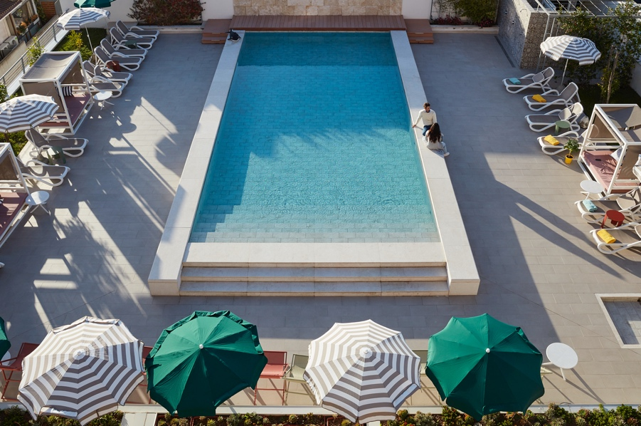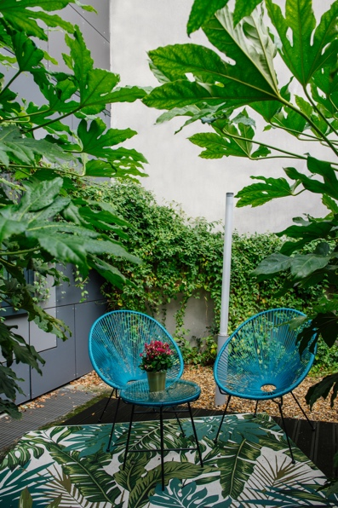

Adagio is renewing its outdoor spaces to offer a design experience, warm and attentive to travellers and locals alike. Real hubs of greenery and activity where guests can share unforgettable moments on the return of the beautiful days!

Adagio has designed its outdoor spaces and architectural style of its interiors with emotion and personality along with maintaining its functionality to create spaces of comfort and connectivity in their own right. The style is contemporary and timeless with the eclecticism of objects, the simplicity of forms and the authenticity of materials, assembled in a harmonious way.

Adagio Original

At Adagio Original, we have a style where outdoor spaces are larger with various configurations: a larger terrace or even several terraces and a rooftop terrace that are often complemented by green areas.

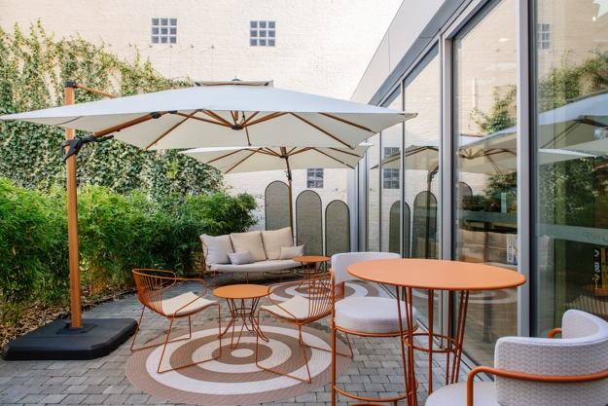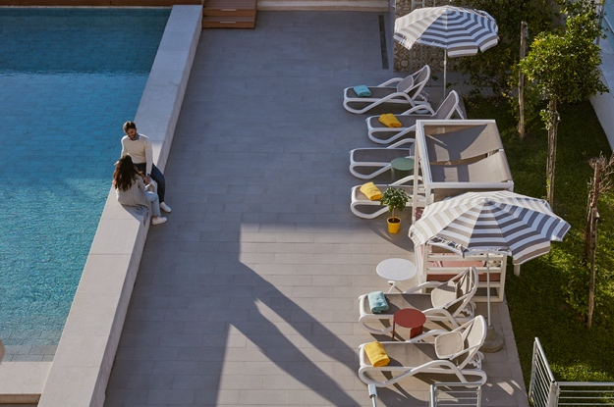

These configurations make it possible to accommodate more people, whether travellers or locals, making it more functional. While the green space is a real asset in an urban aparthotel, long-term travellers benefit from the “nature” experience in the heart of cities.

The outdoor spaces are fitted out by the interior designer for the common areas, with the help of the building architect, who prescribes the materials for the exteriors. The outdoor spaces are often adjacent to the facade of the building and can take two configurations: Configuration open to the neighbourhood; immediately visible to the customer upon arrival at the aparthotel interior configuration or visible to the customer later after having crossed the parts municipalities.

The layout and atmosphere are complementary to the interior spaces, in particular the presence of seating for enjoying breakfast on sunny days.

Some aparthotels have a terrace with an outdoor swimming pool, near the building or on the rooftop. Beyond the outdoor urban experience of a terrace by the water, it is a space for well-being, sports but also for guests to cool off, swim, and relax.

Open during the summer season and on a specific time slot, the terrace with a swimming pool particularly attracts a leisure clientele, such as families and other groups.

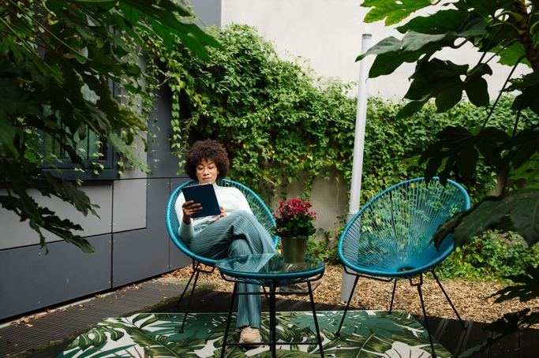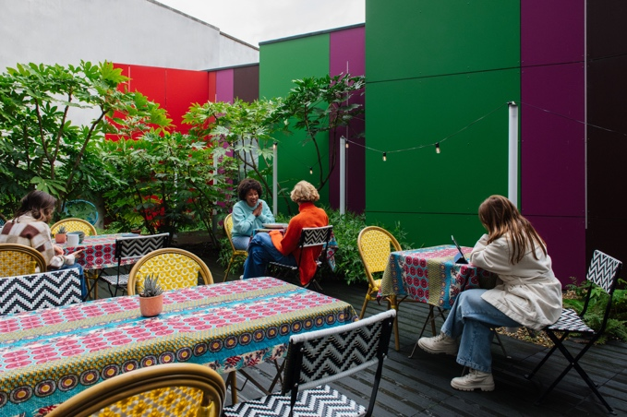

At Adagio Access, the style is there

The furniture accompanies all the moments of the traveller's day by encouraging them to eat, work and have fun. To make the experience unique, gaming is an important pillar of these outdoor spaces, which brings a touch of fun to the customer experience.

The space allow for more diverse experiences, including a dynamic terrace near the breakfast area, letting the traveller choose their desired atmosphere! We find in particular deckchairs, umbrellas and inflatable mattresses or buoys, make the space lively and dynamic.

In the case of separate terraces, the configuration naturally helps to create different experiences with factors that vary from one space to another including the size, amount of sun exposure and surroundings. Finally, the green spaces make it possible to add additional functions from an urban vegetable garden, a petanque or molki court or even an open-air cinema.

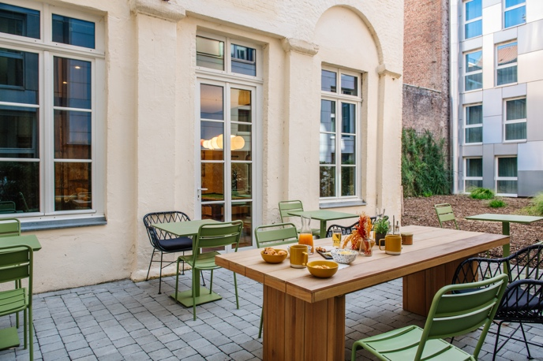

Here is a selection of “HOT-SPOTS” that make you want to sip a drink this summer in France and Europe!

Adagio Original - Lille Center Grand Place
Located in the heart of Lille, the Adagio Original Lille Center Grand Place aparthotel will seduce you with its modern furniture and contemporary and elegant design. In the outdoor areas, relax and have a drink whether you’re alone or with friends.

Adagio Access - Paris-Reuilly
Bright colours and unique designs are the staples of the Adagio Access Paris Reuilly. A cosy atmosphere, conducive to relaxation awaits travellers. An idyllic setting that can serve both as a place of work but also as a place to live.

Adagio Original - Rome Vatican
The Adagio Original Rome Vatican offers a unique stay, in a setting of relaxation and letting go. The large terrace with a swimming pool will entice travellers with its comfortable style. The ideal spot to enjoy by the pool!

+++

About Adagio
Adagio is the European leader of aparthotels. Founded in France in 2007 as a joint venture between Accor and Pierre & Vacances Center Parcs, Adagio boasts 129 sites and 14,071 apartments, located in 16 countries. It is the most extensive aparthotels network in Europe.

Combining the flexibility of a flat with the services usually found in hotels, aparthotels are the best solution for medium to long stays, providing the best value-for-money to business and leisure travelers alike, and to those that like to combine both.

Located in urban areas, Adagio’s aparthotels are divided in 3 ranges: Adagio Original, in the centers of major cities; Adagio Access, in the center of regional capitals or in the direct outskirts of larger cities; and Adagio Premium, high-class aparthotels.

Mason Williams Communications
Mason Williams is a Public Relations agency specialising in Consumer Lifestyle brands. Founded in 1986 we have worked with, and currently represent, some of the biggest and most exciting brands, products and names in the UK and globally through our network IPREX. We have key senior directors based in London, Manchester, Cornwall, and Mallorca to handle our growing Spanish brands.

Visit www.mason-williams.co.uk or find us on Twitter @MasonWiliamsPR, Facebook Mason Williams PR, and Instagram @masonwilliamspr

For further information on Adagio, please contact:
Syamala Upham | syamala@mason-williams.com +44 7825 417148
Iram Khawaja | iram@mason-williams.com +44 7827 062383
Rita Rowe rita@mason-williams.com +44 7711 071451

