Adagio Marks 15th Anniversary and Announces Eleven New Openings for 2023

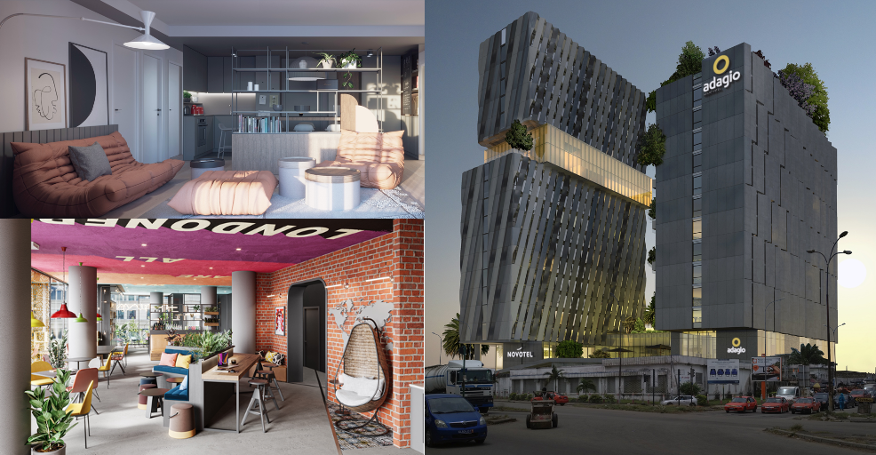

LONDON, XX February 2023 - Europe's market leader in the aparthotel industry, Adagio is celebrating its 15th anniversary this year along with continuing its international expansion by opening eleven new aparthotels across five countries including sub-Saharan Africa for the first time. The expansion follows Adagio’s rebrand earlier this year which unveiled a contemporary, vibrant new look and feel to represent the company’s progression and ambitions for its continued growth in 2023 and beyond.

Thomas Lamson, Chief Development & Projects Officer at Adagio states: “Since inception in 2007 and over the past 15 years, Adagio has largely consolidated its position as the market leader in aparthotels in Europe. The year 2022 was a sign of the resilience of the business model of the aparthotel sector, with numerous new deals and openings as well as an enormous overall performance, which was well above that of 2019 and that of the traditional hotel market. 2022 marked another turning point for Adagio with the creation of a new brand identity, designed by internationally renowned agency Saguez & Partners, which encapsulates Adagio's three key brand values: courage, sharing and taking responsibility. In addition to the eleven planned openings, Adagio 2023 will introduce two new concepts: a new and totally innovative Adagio Access 3-star apartment and the new Coliving Access Apartment. The entire Adagio development team looks forward to presenting the first details at MIPIM (Marché International des Professionnels de l'immobilier) taking place in Cannes from March 14th to 17th.”

Quarter 1 sees the opening of four aparthotels across Belgium and France:

- Adagio Original Antwerp City Centre, Belgium – Located in the heart of Ghent with 100 studios, Adagio is integrated into a mixed-use complex with offices, stores, and apartments as part of its Urban Nest concept.
- Adagio Original Gent - Centrum Dampoort, Belgium – Located in an up-and-coming district, in the neighbourhood of the former docks, Adagio will have 98 apartments and studios for two to four people. The new Adagio is inspired by the "Living Hub concept," meaning Adagio will be a vibrant meeting place within the neighbourhood for guests and residents alike along with people looking for a place to co-work.
- Adagio Access Montpellier Centre Comédie, France – The aparthotel is run in collaboration with a three-star hotel and offers 39 spacious apartments. Previously a senior citizens' residence, the new aparthotel is proud to be demonstrating CSR and sustainability by reshaping and reusing the building.
- Adagio Access Lyon, Comfort Suites Rive Gauche Lyon Centre, France – The second Adagio in Lyon will have 78 studios and apartments in the university district. Adagio Access Lyon replaces an existing aparthotel and will also feature the popular hybrid concept "The Circle" after extensive renovation of the public areas.

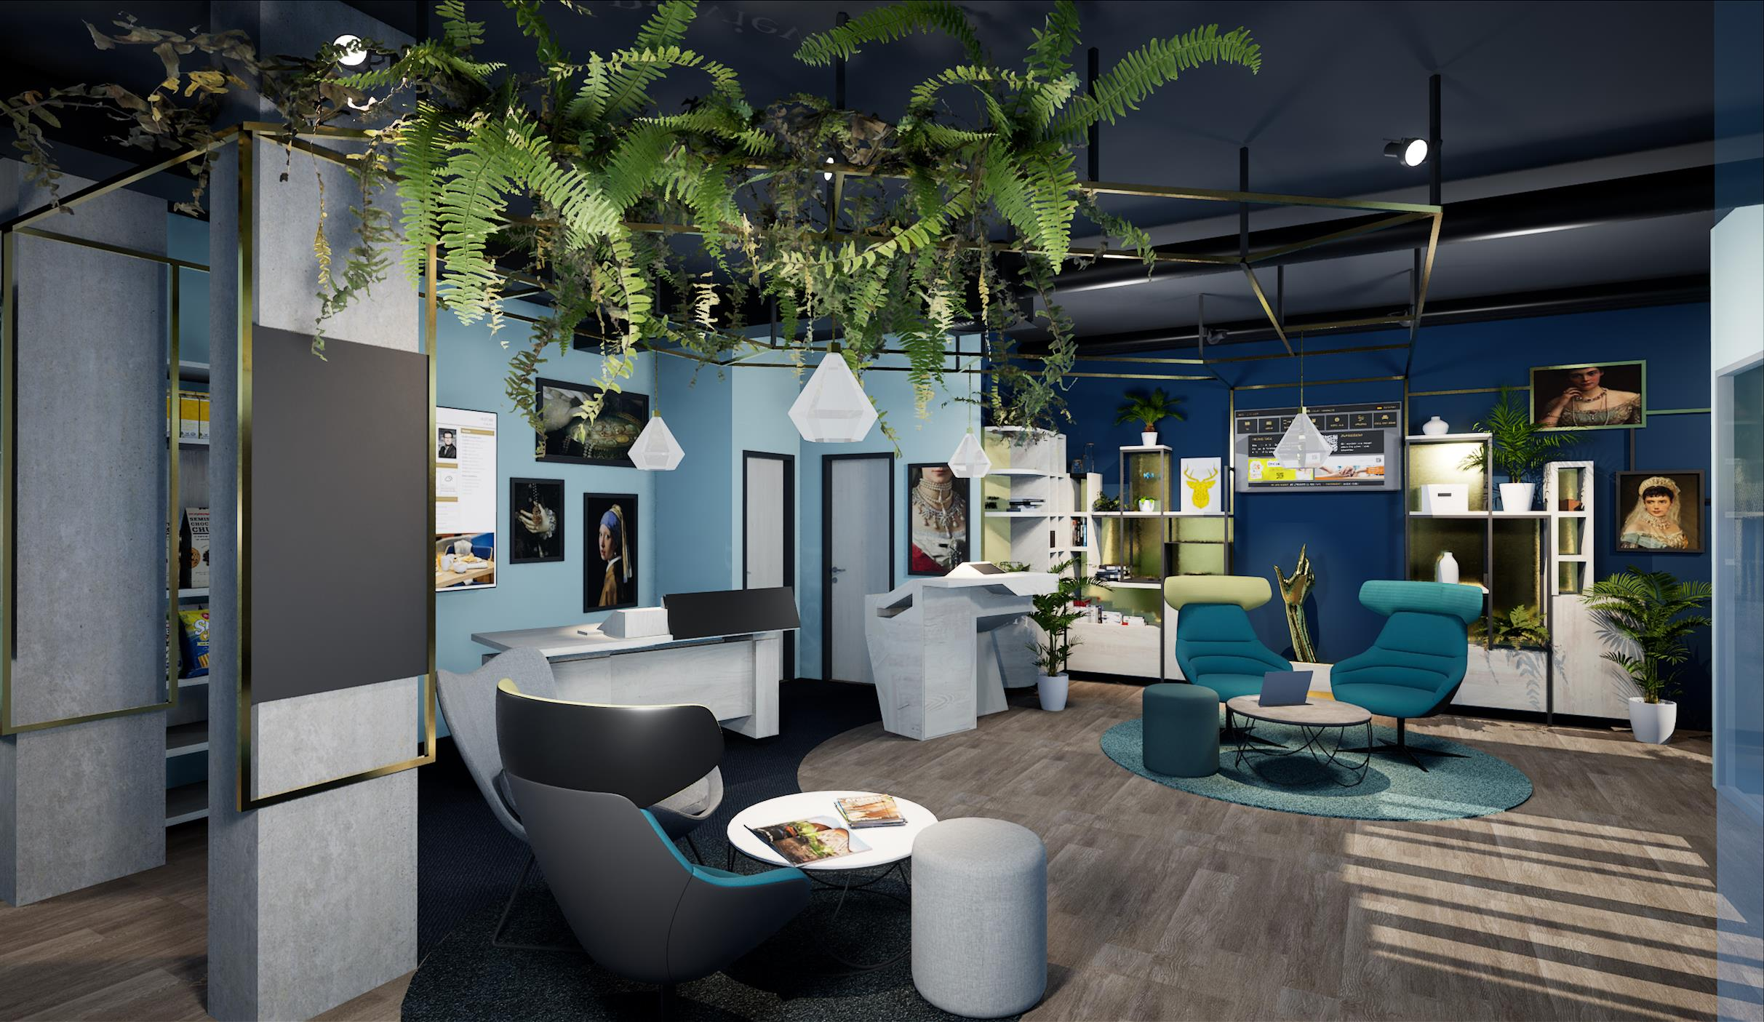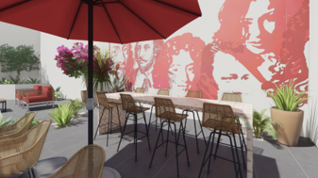

Quarter 2:

- Adagio Original Toulouse - La Grave, France will open in the lively Saint-Cyprien district of the "pink city", as Toulouse is affectionately known. Adagio has taken on a pink tone in the interior design to reflect the city making it discreet, stylish and informal, to fit into Adagio’s rebrand style this year. The Adagio Original Toulouse La Grave follows the "Urban Nest Concept" and is integrated into a mixed complex of flats, shops and offices. A total of 114 two-bedroom flats and studios are available.

In Quarter 3, Adagio will open two hotels in France and the Ivory Coast:

- Adagio Original Boulogne-Billiancourt, France – The new 101-unit Adagio will be located in the heart of the Trapèze district, a dynamic part of the city near Le Seine Musicale, the Parc des Princes football and rugby stadium.
- Adagio Original Abidjan Marcory, Ivory Coast – Adagio will have 100 studios and flats with shared pools and extensive outdoor facilities.

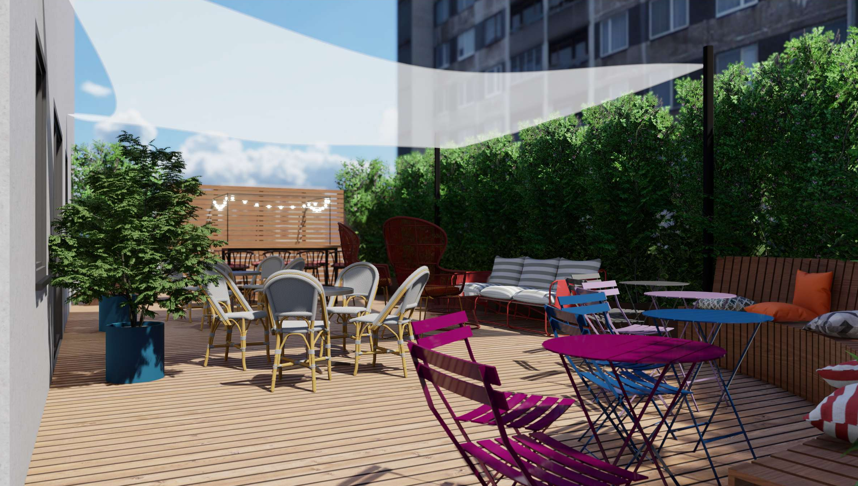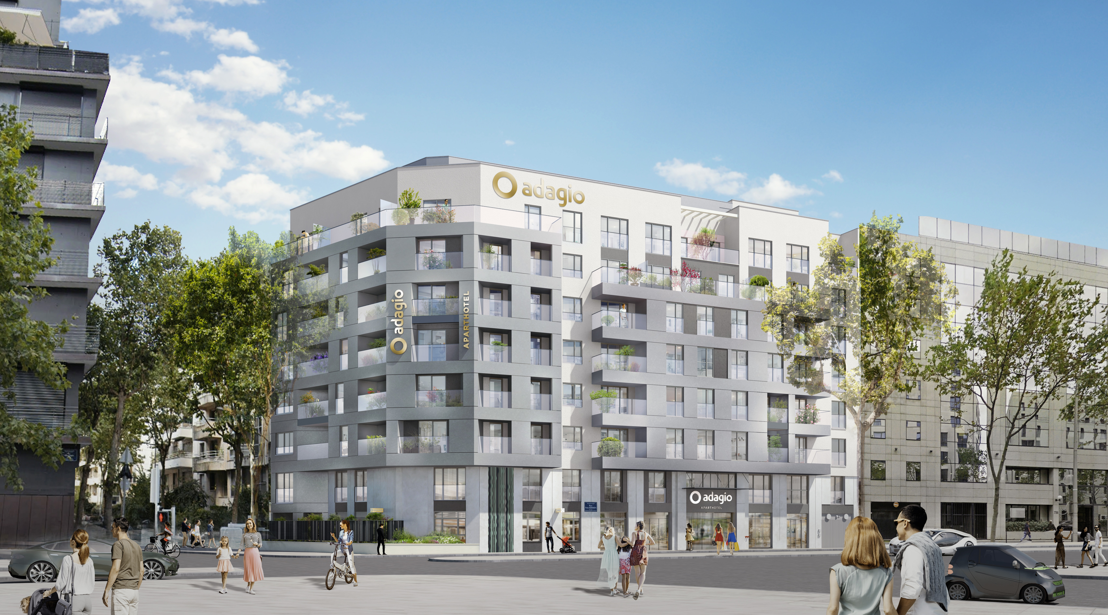

In Quarter 4, Adagio will see the opening of four more hotels in France, Italy, the UK and Germany:

- Adagio Access Rome Colombo, Italy – Located in a lively business district just five minutes from the Baths of Caracalla, near the European Quarter. It will offer 106 studios and flats and has moved into a building that was previously an individually run aparthotel. The hybrid common area "The Circle" with its colourful design offers the opportunity for relaxed working and meeting. The outdoor area resembles an urban jungle and offers a peaceful green space for the city.
- Adagio Access Rouen - Centre, France – A combined project by Adagio and Novotel located near the cathedral and part of a mixed-use complex pursuing its "living hub concept" with 75 studios and flats. The listed façade of the building will be carefully restored and preserved.
- Adagio Original London Whitechapel, United Kingdom – Based in East London, Adagio will offer a total of 147 studios and flats including co-living flats. The Adagio concepts "Urban Nest" and "Smart House Design" merge into one here by installing the first Co-living Apartments outside the pilot project, an innovative concept designed to accommodate larger groups travelling together, meeting and spending a lot of time together either for business or leisure. A Coliving Apartment is fully equipped like a flat perfect for a longer stay - for living, sleeping and working.
- Adagio Original Heidelberg, Germany – The Adagio Original Heidelberg will be located next to the main railway station with 162 studios and flats offering the "Smart House Concept" and become the Adagio Original flagship aparthotel in Europe. It will set future-oriented standards in terms of design and is the first time the Adagio team is collaborating with INNOCAD Architecture, a successful architecture firm based in Graz, Austria.

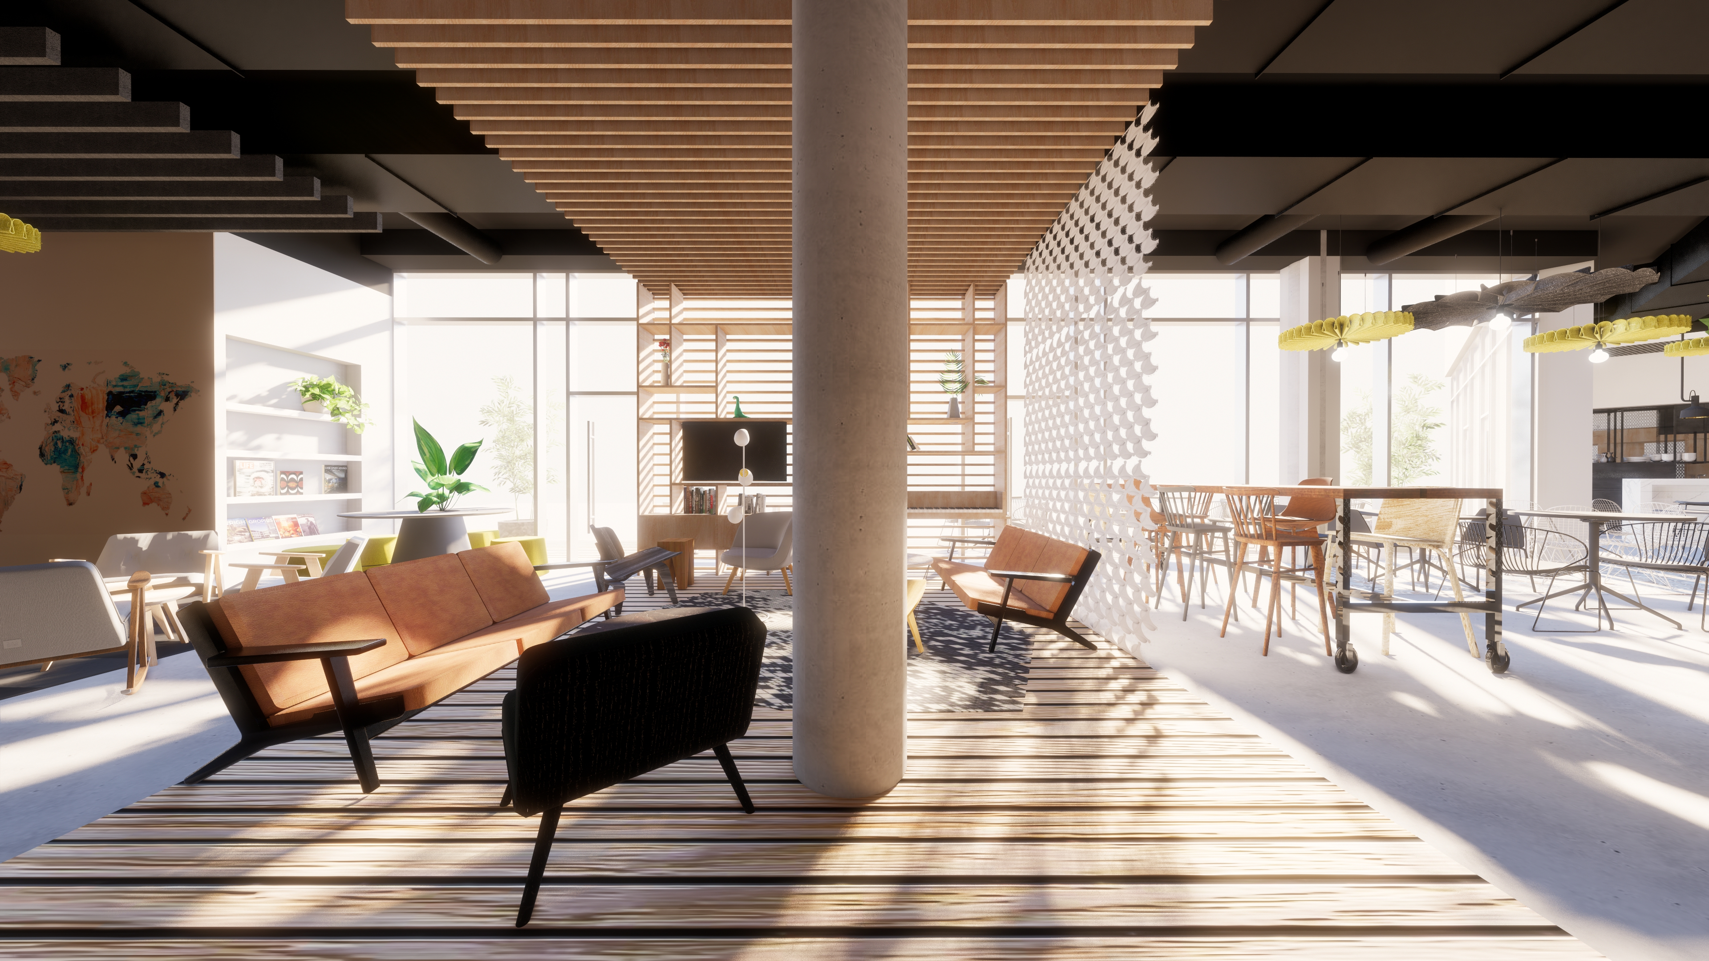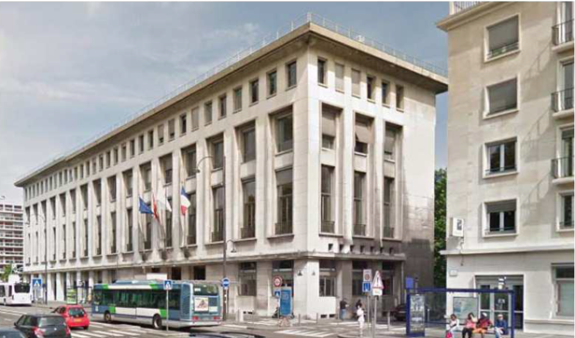

-ENDS-

About Adagio

Adagio combines the comfort of a flat with the service of a hotel for that extra convenience. Mainly found in city centres and sought-after regions. The innovative company Adagio was founded in France in 2007 as a joint venture between Accor and Pierre & Vacances Centre Parcs. The idea was to offer a concept for the needs of long-term travellers. What was originally 16 aparthotels in two countries has now become a rapidly growing company with the aim of being present in Europe as well as in the Middle East and Latin America. Today, Adagio is the European market leader in the aparthotel industry and aims to expand its network to a total of 200 aparthotels with 15,000 flats by 2024. The three product lines are: Adagio Original: the heart of Adagio; Adagio Access: the smart Adagio; Adagio Premium: the exceptional Adagio.
www.adagio-city.com

Find Adagio on Instagram, Facebook, LinkedIn and Youtube.

For more information visit Adagio and follow them on Instagram, Facebook and Linked In.

Mason Williams Communications
Mason Williams is a Public Relations agency specialising in Consumer Lifestyle brands. Founded in 1986 we have worked with, and currently represent, some of the biggest and most exciting brands, products and names in the UK and globally through our network IPREX. We have key senior directors based in London, Manchester, Cornwall, and Mallorca to handle our growing Spanish brands.

Visit www.mason-williams.co.uk or find us on Twitter @MasonWiliamsPR, Facebook Mason Williams PR, and Instagram @masonwilliamspr
For further information on Adagio, please contact:
Syamala Upham | syamala@mason-williams.com +44 7825 417148
Iram Khawaja | iram@mason-williams.com +44 7827 062383
Rita Rowe rita@mason-williams.com +44 7711 071451

